**NAME:PAREENITA A.SHIRSATH ROLL NO:52 T.E.A.I.&.D.S. PRN:221101062**

**EXPERIMENT NO:7**

**1.STAR TOPOLOGY:**

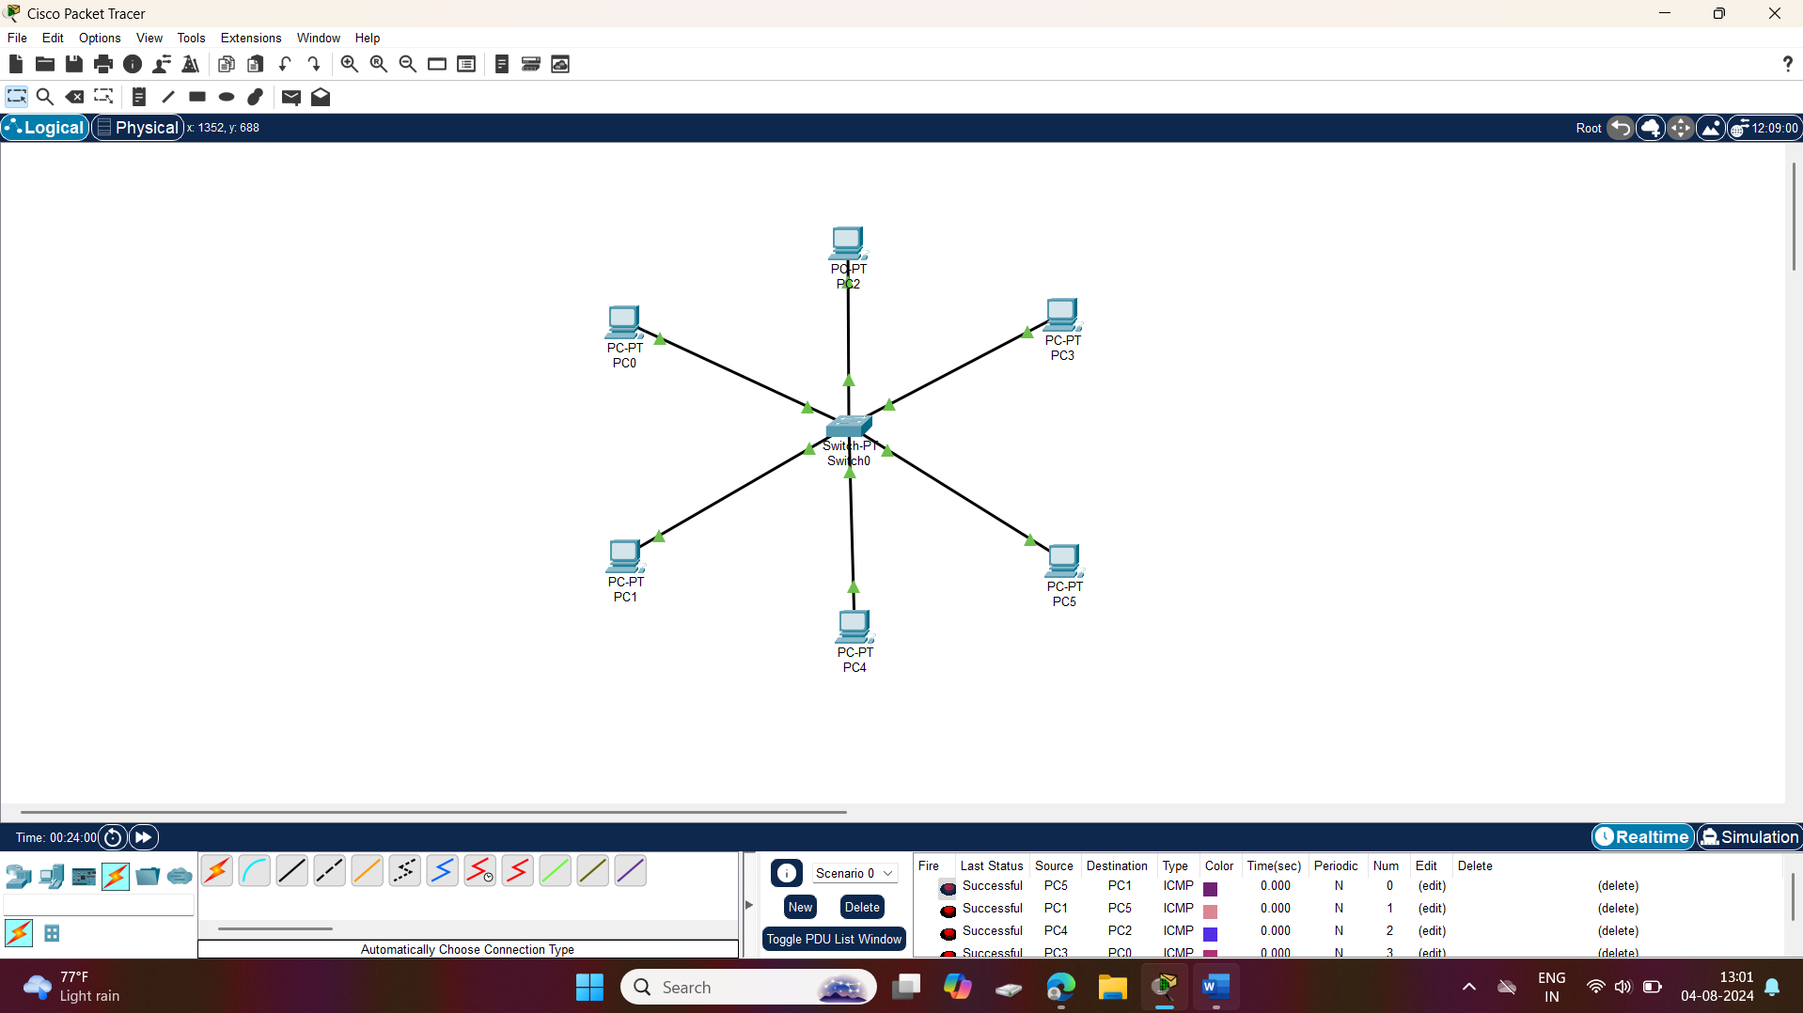

**2.BUS TOPOLOGY:**

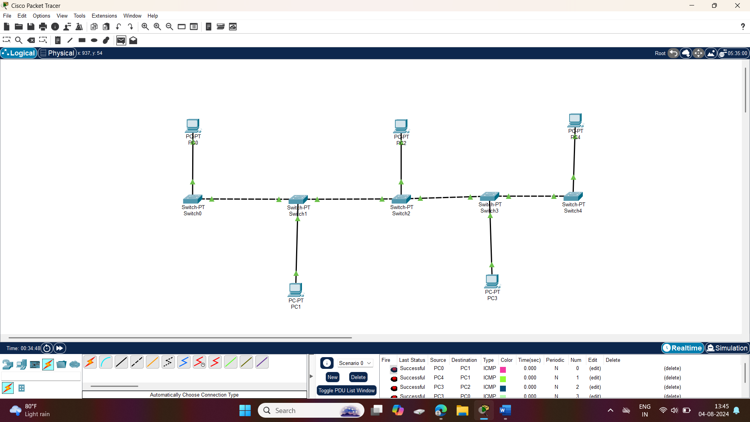

**3.RING TOPOLOGY:**

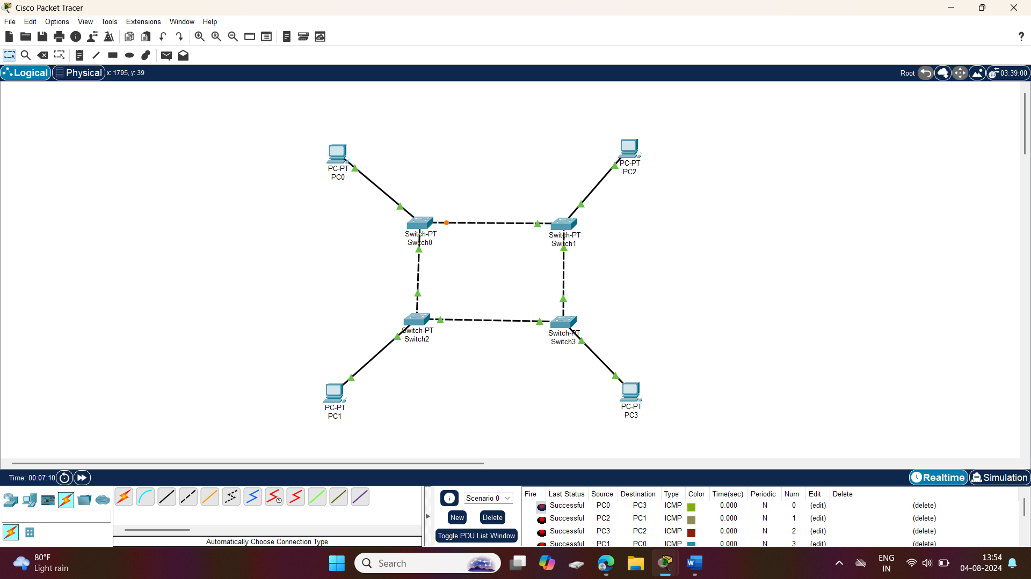

**4.MESH TOPOLOGY:**

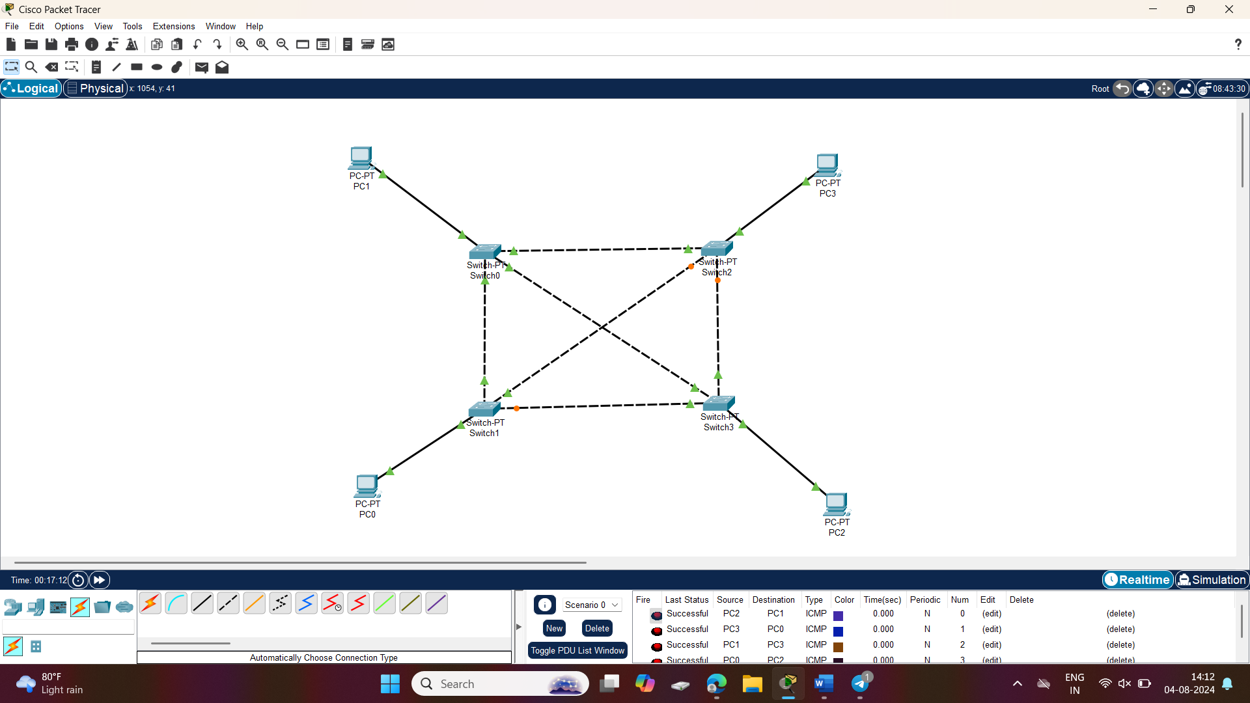

**5.TREE TOPOLOGY:**

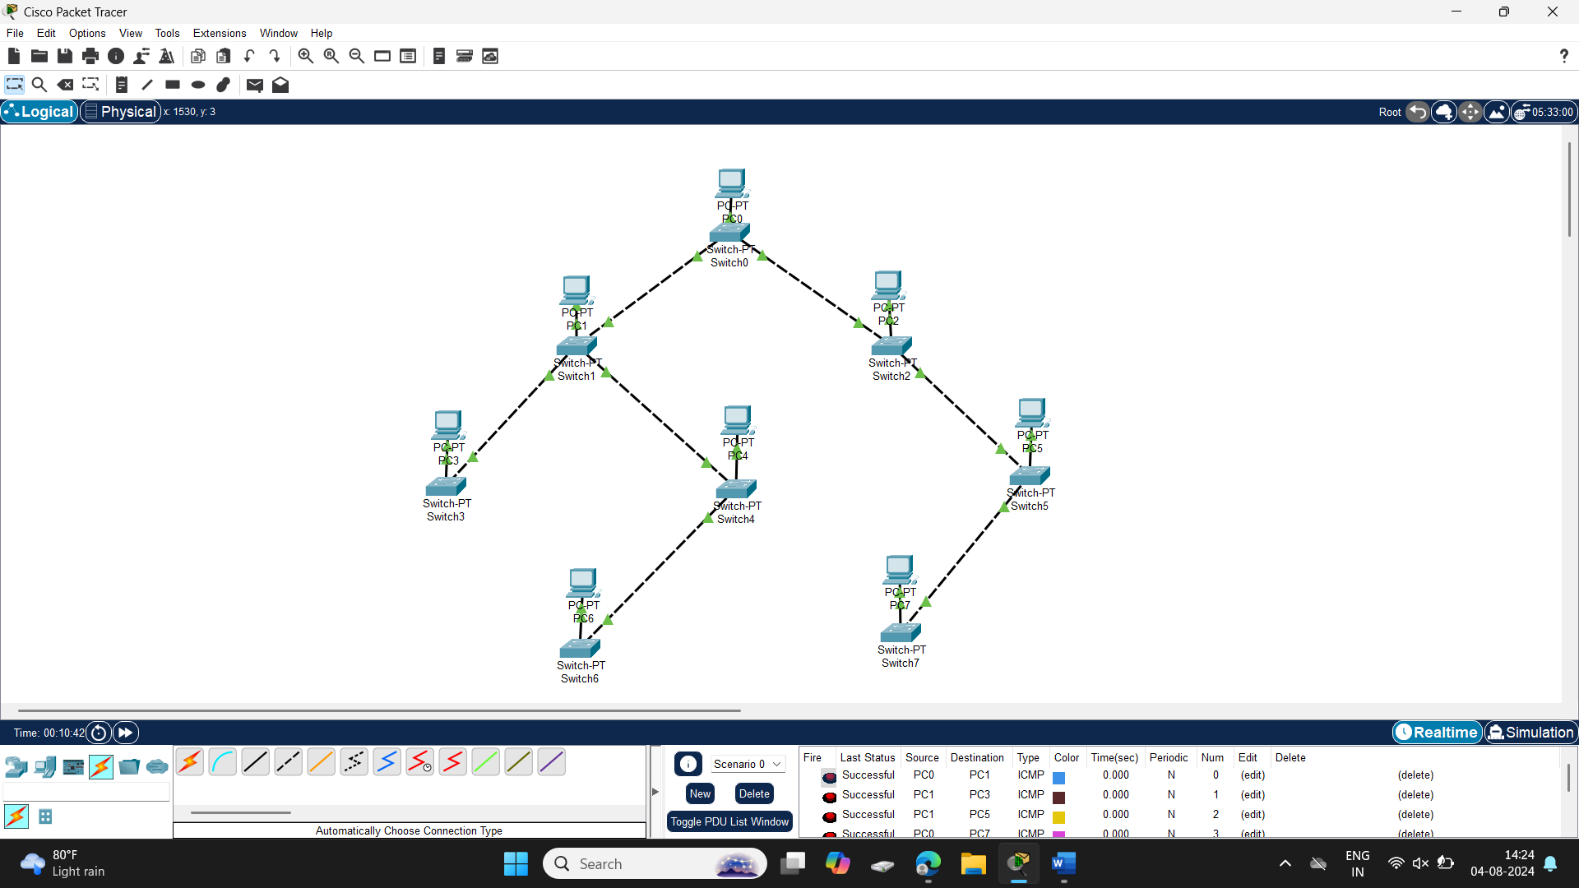

**6.HYBRID TOPOLOGY:**

